B3.2 Pre-Test

- Which is the best definition of an ecosystem? [1]
Tick ( ) one box.
- The place where an organism lives | 
- The interaction of a community of organisms with the non-living parts of their habitat
- The relationships between animals that can be represented using a food chain

- What resources do animals compete for? [1]
Tick ( ) one box.
- Light, water and space
- Space, mates and food
- Food and water

- Which of these is always the first stage of a food chain? [1]
Tick ( ) one box.
- Producer
- Consumer
- Herbivore

- What do plants need to be able to photosynthesise? [1]
Tick ( ) one box.
- Light and water
- Oxygen and glucose
- Light, water and carbon dioxide

- Which is the correct definition of a population? [1]
Tick ( ) one box.
- A group of organisms of the same species
- A group of animals in a specific habitat
- A group of different species in the same habitat

- Which of these is a biotic factor? [1]
Tick ( ) one box.
- Temperature
- Food availability
- Water availability

- Which method of sampling would be used to estimate the number of daisies in a field? [1]
Tick ( ) one box.
- Random sampling
- Systematic sampling
- Using a quadrat

Use the following food web to help you answer Q8 – Q10.
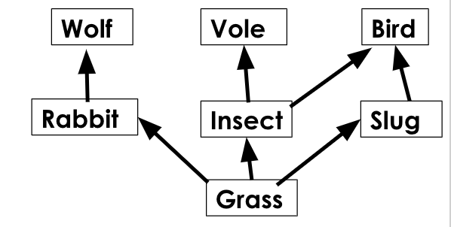

- Which term could be used to describe the rabbit? [1]
Tick ( ) one box.
- Secondary consumer
- Predator
- Herbivore

- Which of these species could be described as a primary consumer? [1]
Tick ( ) one box.
- Wolf
- Grass
- Slug

- A new disease has affected the rabbit population. Which of these could be a consequence of this? [1]
Tick ( ) one box.
- The population of wolves would increase
- The population of wolves would decrease
- The biomass of grass would decrease

